ManuConnect Release - 2020.09.21

Exported on Sep 21, 2020

Table of Contents

1 Overview 4
2 Enhancements 5
3 Defects Addressed 9

Release Date | 2020.09.21
Core Installer
Installer Suite

Overview
Several tickets on PAD are resolved today. There are also enhancements made to the VO API.

Enhancements
Feature | Client No. | Category | Summary | Release Notes
MLU-734 | - | Accounting | Handling of Payment line (split) items | The following changes and UI improvements were made to support commit of multiple payment line items:  Batch Item Modal:  - Committing a payment line with split items will be performed in the same commit (instead of separate commits).  - Reallocating a process payment line will now support split items.  - A list of payment items is displayed under amount summary screen. This will include all batch items of the payment line and a "[New Item]" when adding a new item.  - Payment items for the current payment line will be displayed and can be edited or removed.  - Post button added to support posting batch items and including split items.  - Renamed and appropriately enabled/disabled the commit buttons. Commit will only be supported when a change has been posted or item has been removed.  - Change indicators will display when the modal is closed or an action that will result in loss of data entry.  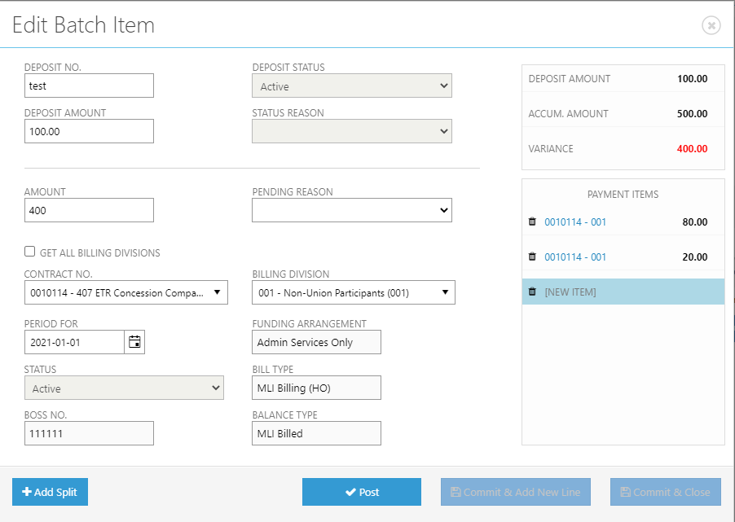  Batch Details:  - Added "edit" icon for the parent payment line (on selection the first item will be auto selected in the batch item modal).  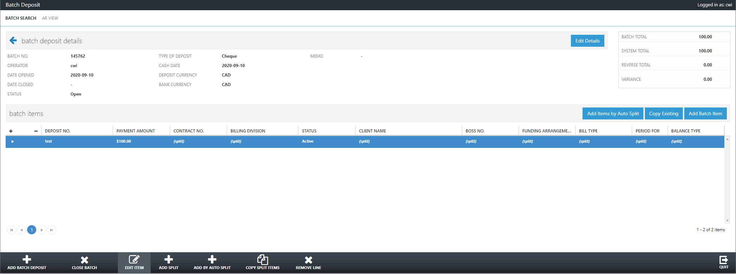
VO-2249 |  | Web Service | Expose CorrelationId for NLog | Passed `CWI-CorrelationId` header will be available in NLog as "correlationid".  Here's a sample line from from NLog.config:
VO-2229 |  | Web Service | VoApi: Use redis \ in memory cache | Made the following enhancements to VOAPI with caching:  - Added a new VOAPI.Caching project. The caching logic is derived from the existing caching found in VOAPI.Client with some additional methods.  - Centralized the loading and caching when retrieving Member Plan Info. This impacts the endpoint "Member/{memberId}/PlanInformation" as the current member will be cached after an initial retrieval.  - Centralized the loading and caching when retrieving Client Plan Info. This impacts multiple endpoints that retrieve member > client plan information. Multiple members using the same client plan/revision will benefit after an initial load.  - Added new configuration in the web.config of VOAPI: useNoCache (defaulted as false). This will allow bypass of the caching functionality.  - Added new configuration in the web.config of VOAPI: cacheDurationMinutes (defaulted as 10 minutes). This will allow bypass of the caching timeout.
VO-2228 |  | Web Service | VoApi: Update swagger to have information about optional parameters. | Updated VOAPI Swagger to display an "Implementation Notes" section which displays the path including all optional parameters (relative path):  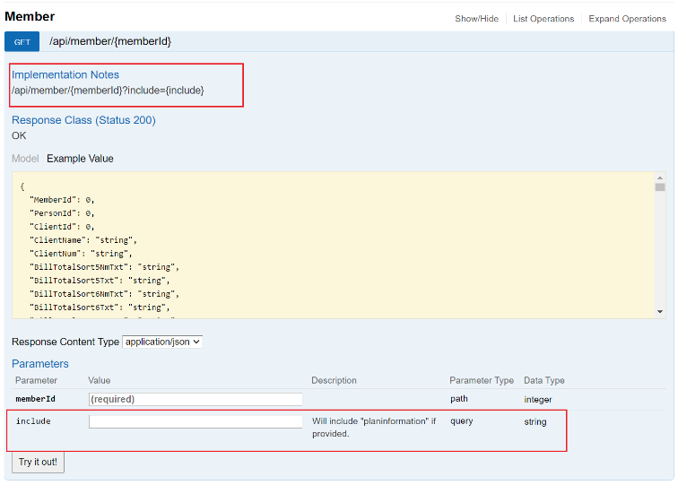  Updated VOAPI Swagger to describe the ApiQueryParameters as optional query string parameters:  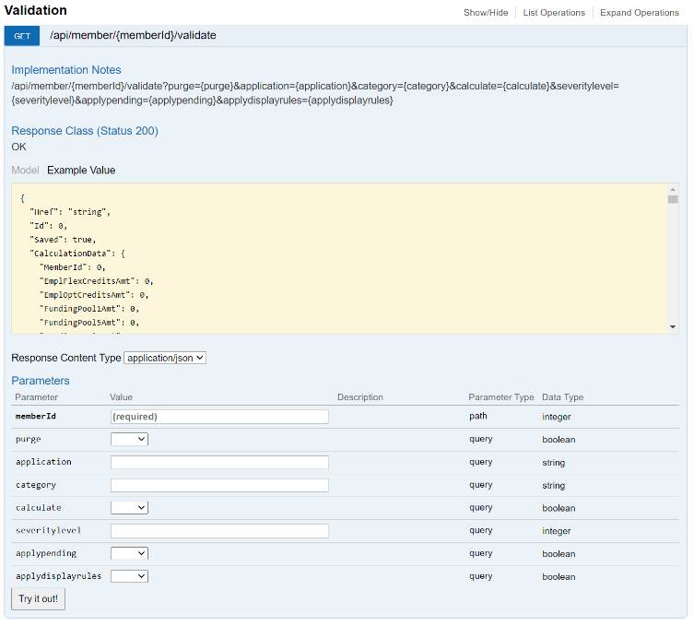
VO-2226 |  | Services | VoApi: Include PlanInformation conditionally in the get member endpoint | Modified the get member endpoint to receive an optional query string parameter "include" which when provided the "PlanInformation" text will return additional plan information.
VO-2225 |  | Services | VoApi: Performance improvements in the "api/member/{memberId}/planinformation" endpoint | Modified the member plan information API endpoint to retrieve basic member information via a SQL query instead of using Member Init functionality from business objects.

Defects Addressed
Defect | Client No. | Category | Summary | Release Notes
MLU-749 | 10267 | Admin GUI | [CDTASMU-10267] Member Maintenance: Stop Enrolment, Addressee2, Contract #, Personal Health Number, Health Num Type | The following items have been changed to match the appearance in VO 4:  - Stop Enrolment  - Addressee2  - Contract #  - Personal Health Number VO4/Prov Health Num VO7  - Health Num Type vs. Participate BCMSP
MLU-726 | 2532 | Accounting | [CDTASME-2532] VO4 vs VO7 Batch Deposit/Transaction Register differences for PAD field | Various fields on the Transaction Register display are modified to match the VO 4 desktop application.  - Deposit type is changed to 5 (PAD Monthly)  - Cash date is now populated  - Deposit No. remains "EFT"; it is reserved for additional information that may required for the PAD/EFT process.  - In Transaction Register, the type of a transaction is augmented with the Deposit Type label if the transaction's origin is a payment batch. For example, if a payment is from a "Cash Control VO" batch, then "Cash Control VO" will be displayed instead of the true VO transaction type, which is "cheque". Note that in case the said transaction is reversed, then the label of the reverse transaction is also augmented with the same label, which is "Cash Control VO" in this example.
MLU-729 | 2535 | Accounting | [CDTASME-2535] Inconsistent results for 2 runs of PAD job for PAD Account Setup Withdrawal date advance | Root cause:  During the refactoring for parallel processing the skip-next function and advance-draw-date functions were separated for technical reasons. The advance-date function is not executed if there is no payment line item created. If skip-next is executed then advance-date is necessary; otherwise, the account might be processed again in a subsequent run which may be ahead of the next scheduled date.  Resolution:  The skip-next and advance-date functions are carried out together. The withdraw date is now advanced even if skip-next is applied.
MLU-736 | 2547 | Accounting | [CDTASME-2547] PAD Payment Number To be generated | As per request, on the basic payment record, field 6 , character position 22-40 contain the unique string –  Example : MC0112000038374  Where  - MC = Constant for all records  - 0112 = A number which is unique to that PAC payment batch file. So far we already have around 415 batches of files generated. Which means it will be a good idea to start with a number of 500. I mean, from the time VO7 moves to production, first PAC file generated should have 0500 in this place  - 000038374 = ClientLocation ID  These will sum up to 15 characters. Rest 3 characters can be left blank when we send to bank.
MLU-721 | 2516 | Accounting | [CDTASME-2516] PAD process not taking funding arrangement for the most recent/current plan revision that exists | The scenario in this issue is that there is an ASO balance but no insured balance. The program ignored the ASO balance and did not issue an EFT. The issue is now corrected.

